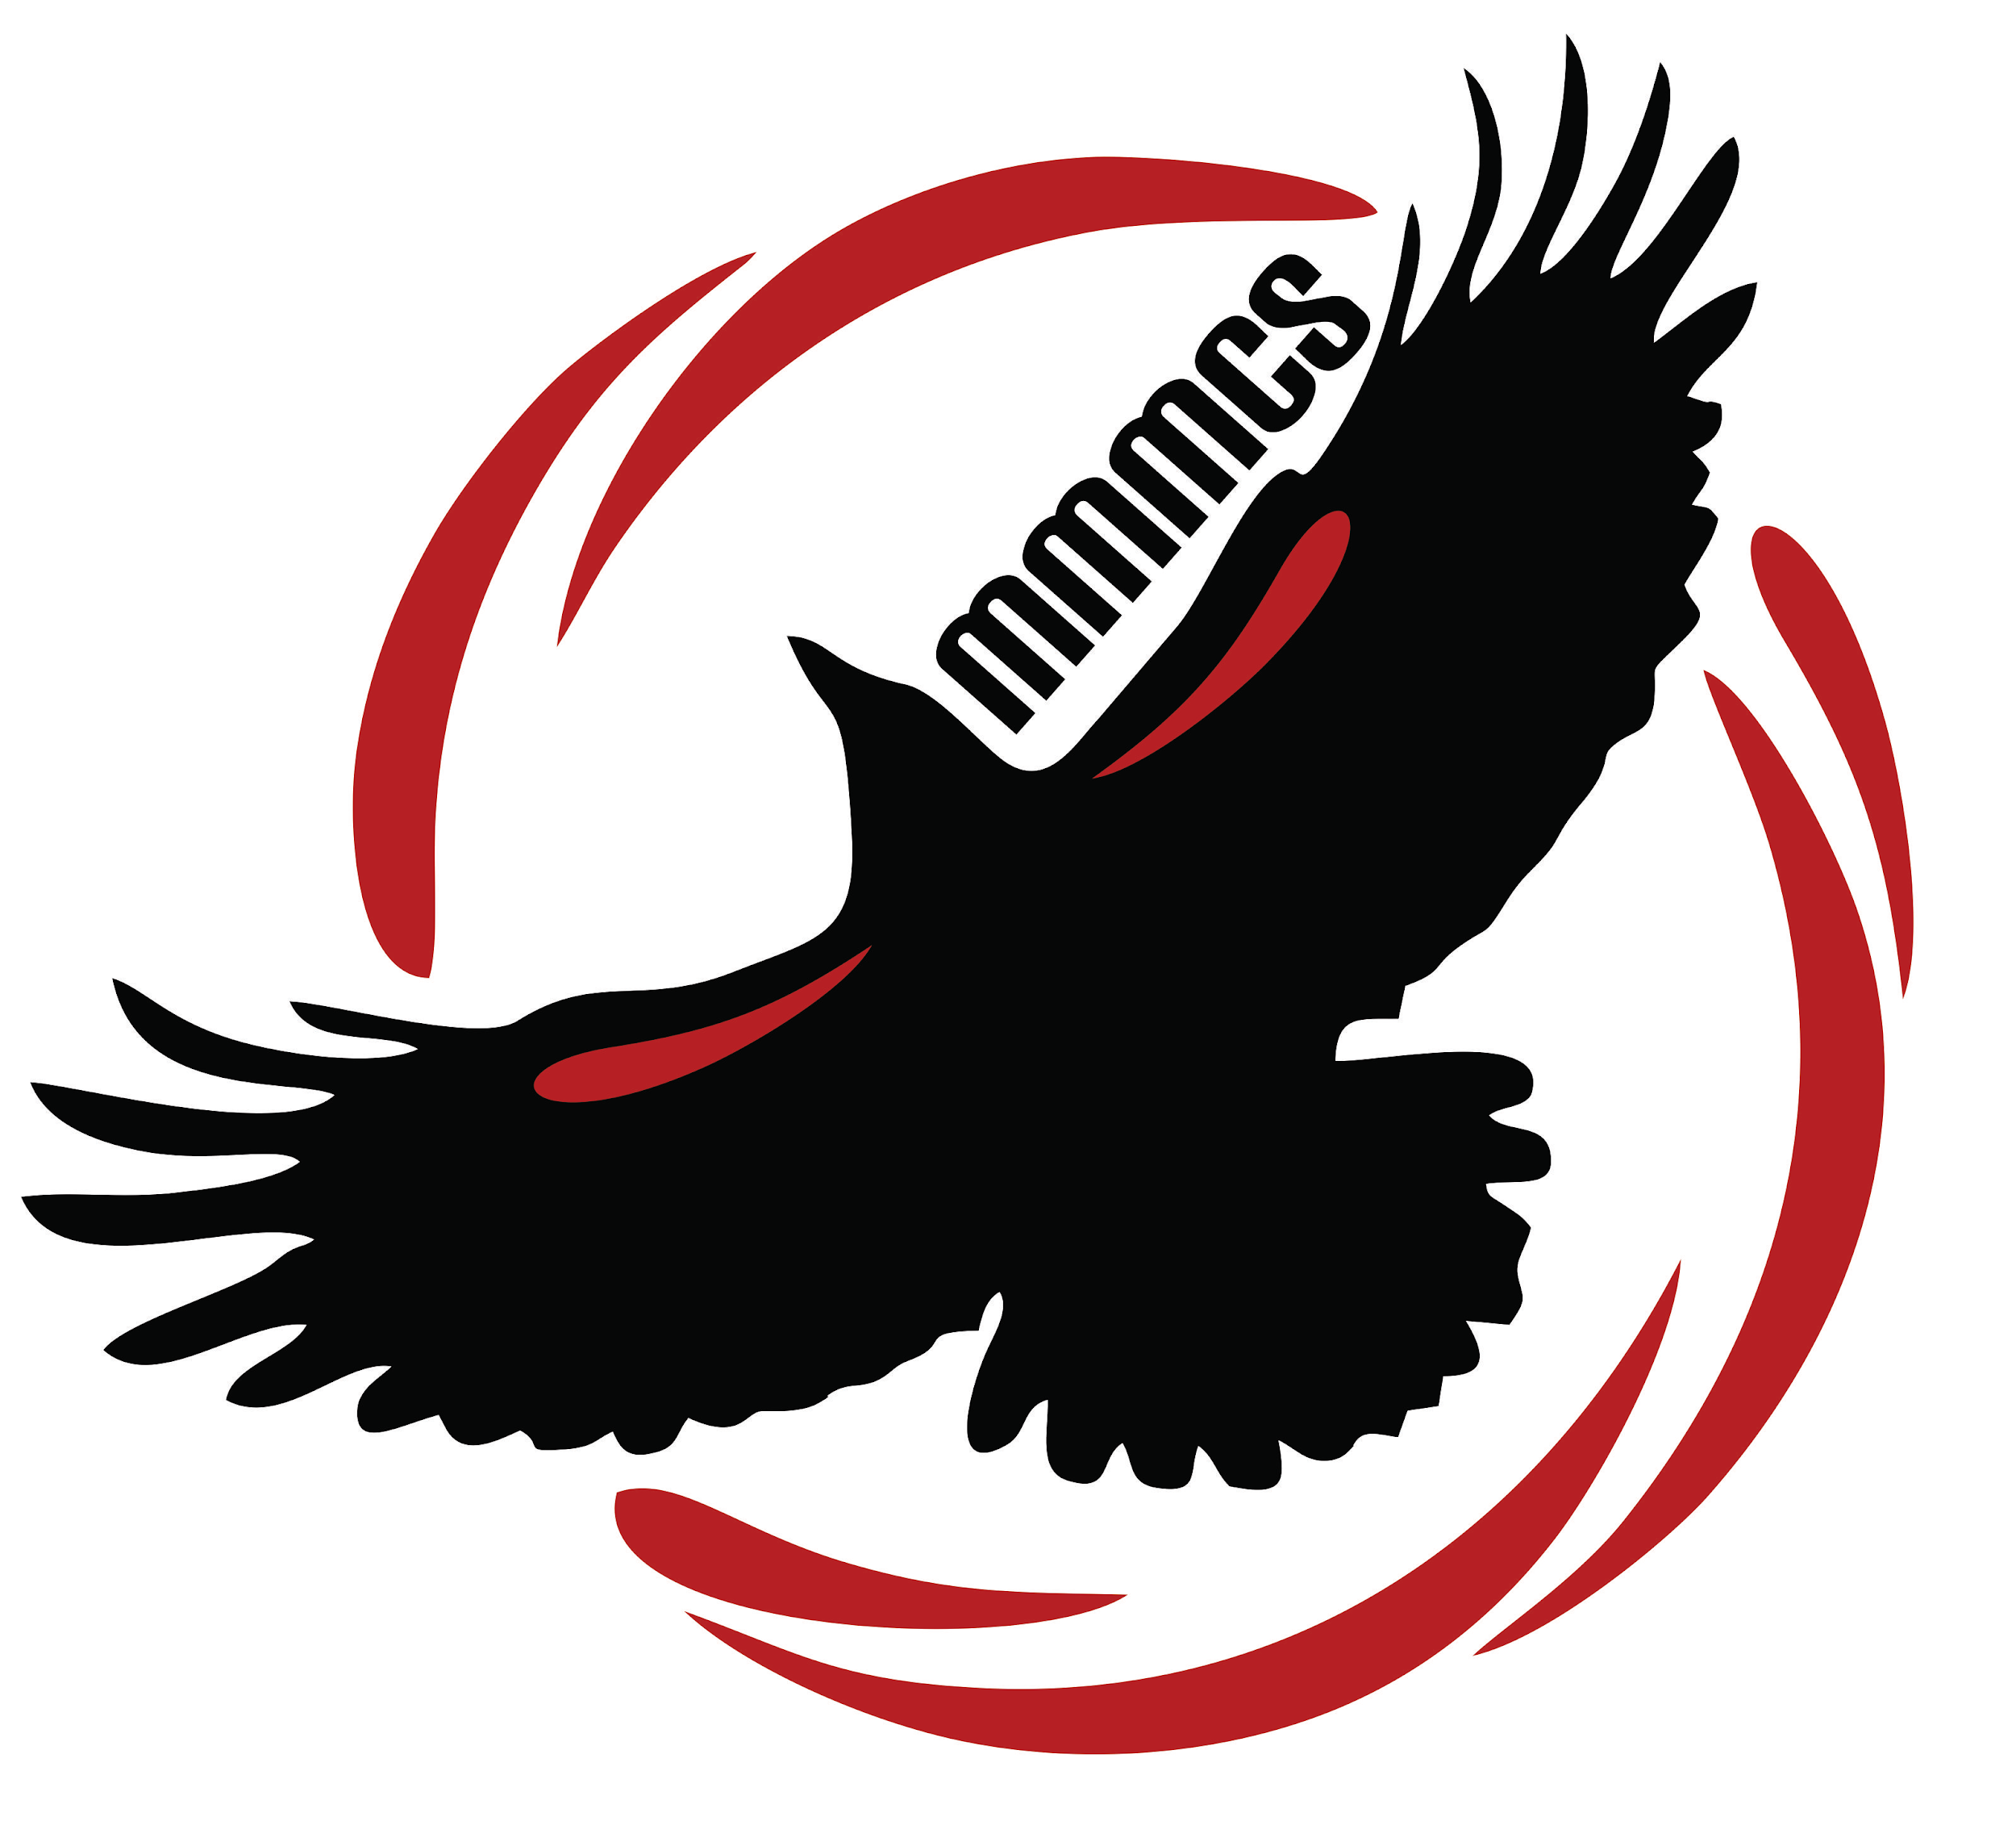
Margaret “Ma” Murray
Community School
11504 - 105 Avenue
Fort St. John BC V1J 0R8
236-365-6627

Monday, September 17th, 2018

Dear Parents and Guardians,

We have now been in session for 9 days. What a great start up we have had! Students and staff seem to be settling in nicely. The kindergarten and daycare playgrounds are being installed and shortly our main playground will be getting installed too. Most of our furniture has arrived. We can now use our whole gym for gym classes! We have so many people to thank for all the work that has been done and is continuing to be completed. To all of the volunteers who have given so much of their time, we thank you. To all the School District staff, particularly maintenance and Mr. Doug Boyd (Superintendent of Special Projects), we thank you. To our custodial staff, bus drivers, secretary, and support staff, we thank you. And to all of the students and parents, we thank you for the words of encouragement, best wishes and excitement. It is great to see children from 6 different schools along with all of our newcomers to Fort St. John becoming friends and being inclusive learners. Please see some updates and reminders below.

Grand Opening: School District #60 will be hosting an official Grand Opening with the Minister of Education on Thursday, September 27th at 1:00 p.m. The students will be attending this celebration and we encourage parents who are able to join this celebration too. We will follow this grand opening with an Open House from 6:00-7:30 p.m. Please feel free to join us in the evening and tour the school, meet the staff and mingle with the other families that are attending our school.

School Meals Program: Students who have signed up for school meals will have their meals delivered to their classroom starting Monday, September 17th. Menus

for October will go out shortly. We do not have canteen items for purchase yet and are hoping to have that up and running by October.

Forms: This week you will receive many forms. Some classes were able to get these out on Friday with the balance of classes sending the forms home this week. All students will receive verification forms and a permission slip for publication of photos for the Ministry of Education Grand Opening.. Please return these forms as soon as possible. Students will also be bringing home fee schedules. This outlines what your fees are for the school year including: school supplies, bus , cultural, agenda and for grade 6 ipad fees. We are not completely set up yet for banking so please do not feel pressured to send fees in.

Mountain West Photos: School pictures will be taken on Wednesday, October 10th. Students will receive personal order forms prior to picture day and these must be returned by October 10th. There is a discount you can pick up from the office if you have 3 or more children receiving pictures through Mountain West. Please drop by the office if you qualify for this discount.

Indigo “Adopt a School Campaign”: Margaret Ma Murray Community School is part of the Adopt a School campaign. The information can be found at: https://adoptaschool.indigo.ca/eng/schools/2239 . This is a great way to assist our school in developing our library collection. Our local bookstore, Coles Books co-sponsors this campaign. All funds donated will be spent at Coles Books. We would like to thank Coles Books for sponsoring this campaign and providing a 30% on books purchased through this program. Donations can be made on line from September 15th-October 7th. You can also share a story on line through the website and that story qualifies us for a free book. Thank you for your support.

Sports Programs: Thank you to Mrs. Logeman and Miss Jaimelia for support our after school programs by volunteering to coach cross country running and soccer. Our students are fortunate that these programs are offered so soon after opening. Over 40 students are participating in these activities.

H.E.R.O. Theme: The school has been using a H.E.R.O. theme with the students over the past two weeks. This relates to our Code of Conduct, behaviour matrix, and is encouraging all students to be an everyday hero like Margaret Ma Murray herself. We will focus some of our assembly time and classroom instructional time to discussing everyday heroes like Terry Fox. A hero is classified as an everyday person doing extra-ordinary things. We encourage families to talk about what a regular person can do to help the world in the smallest of ways. Together we can make this world a better place.

Orange Shirt Day: Over the next few weeks, students will be learning about residential schools and Orange Shirt Day. This day has been set aside to re-affirm that “Every Child Matters”. Phyllis Webstad, the author of The Orange Shirt Story, writes about her experience at a residential school in B.C. She can be considered a HERO as she bring knowledge and understanding regarding residential schools and the truth and reconciliation process in Canada. Please see the website link http://www.orangeshirtday.org/ to learn more about this important day in our Canadian history.

Lost and Found: We are getting quite a few lost and found items at the school. For now, they are on display in the Bella Yahey Gathering Space. We will be placing lost and found boxes in each pod soon and hope that students will look there for missing items.

We look forward to meeting all families before the end of September.

Sincerely,

Mrs. Kathy Scheck Mr. Hunter Mackay Mrs. Linda Gibos
Principal Vice Principal Secretary

Margaret Ma Murray Community School

Updated Monthly Calendar

September and October
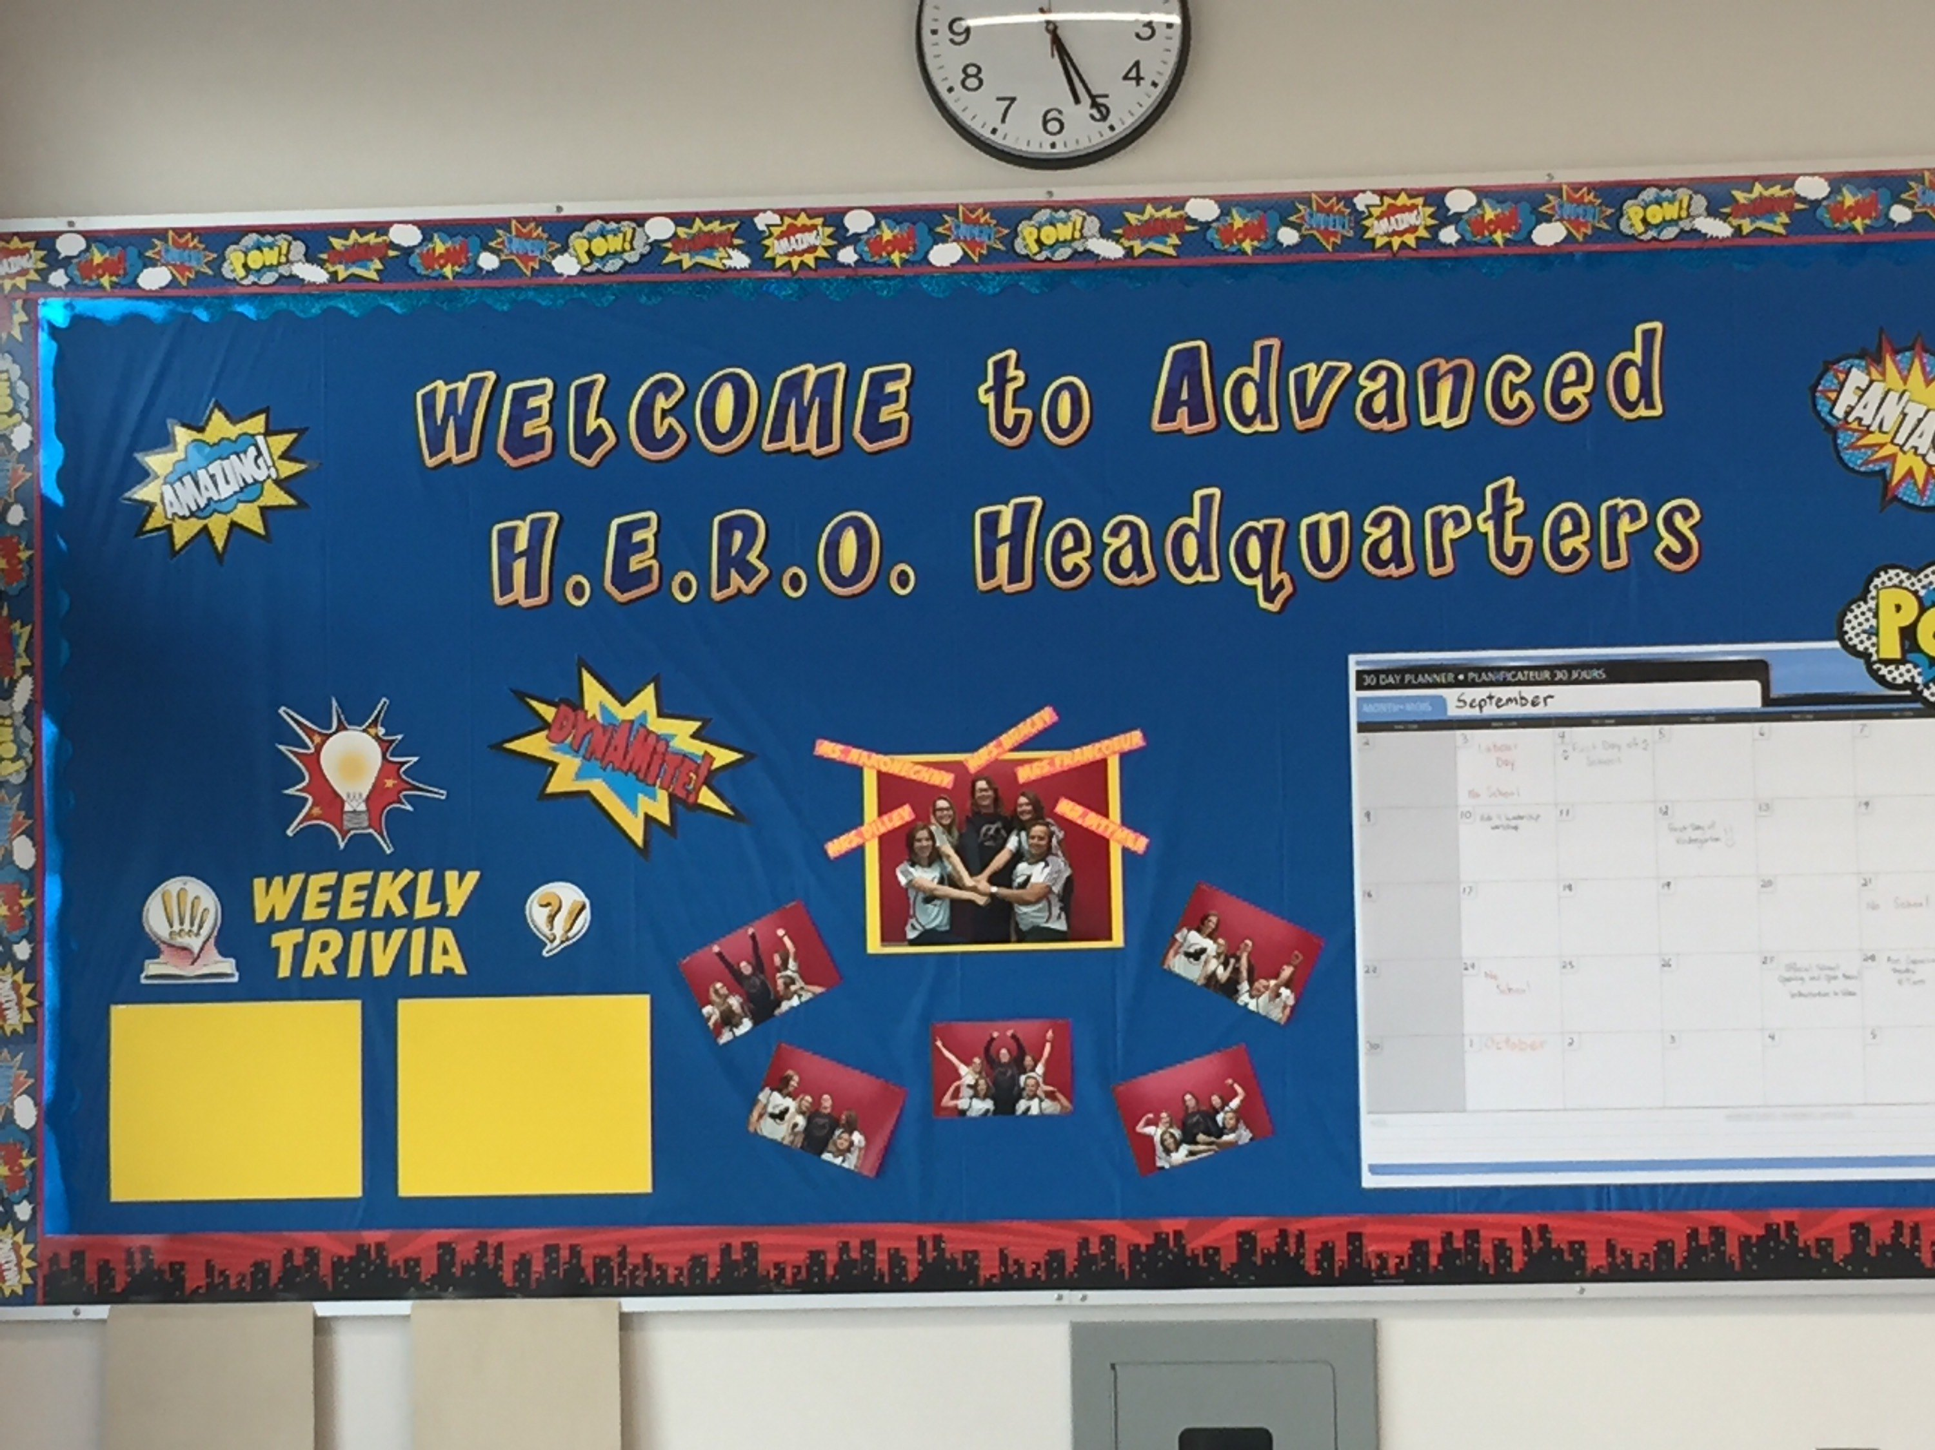
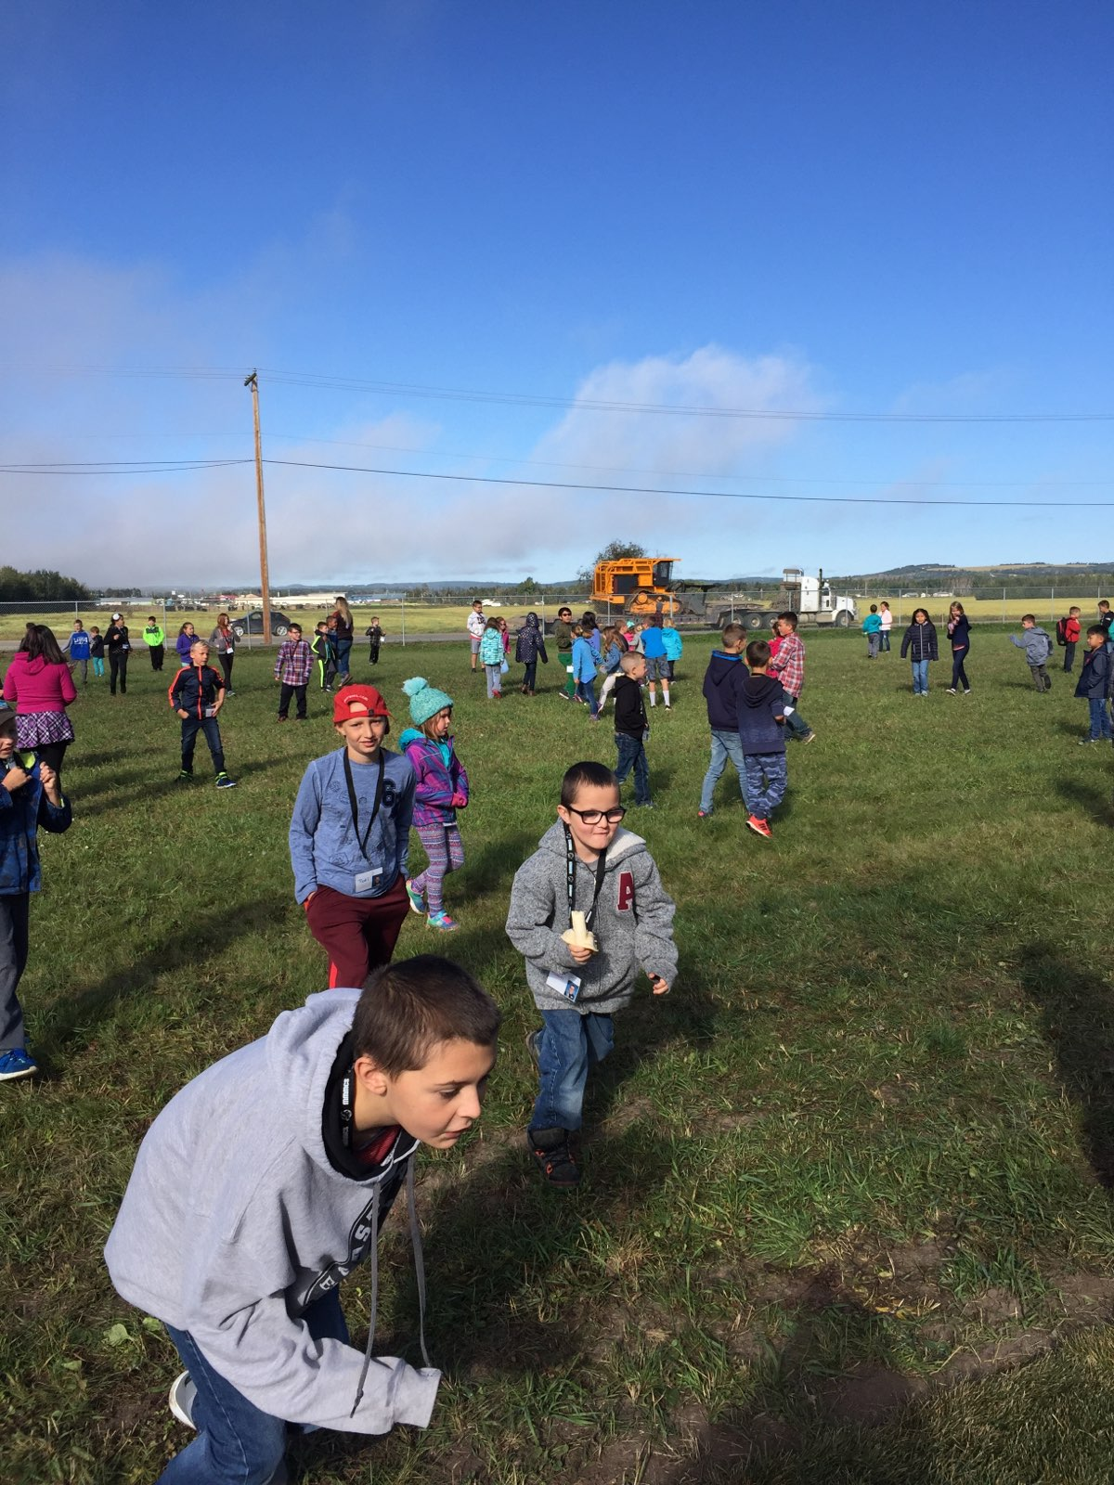
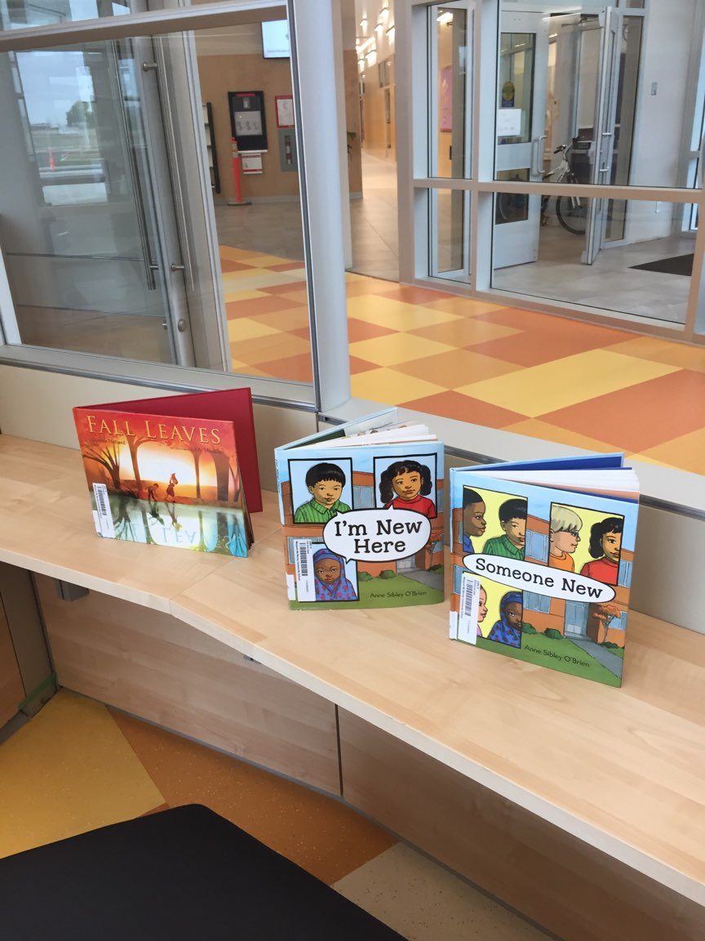
Monday | Tuesday | Wednesday | Thursday | Friday
17  Assembly @ 9:00 a.m. | 18 | 19 | 20 | 21  Non-Instructional Day Planning  School Closed
24  Non-Instructional Day  Pro- D  School Closed | 25 | 26 | 27  Grand Opening @ 1:00 p.m. and Open House  6:00-7:30 pm. | 28  Axe Capoeira Theatre @ 9:00 a.m.  Terry Fox Run
October 1  Orange Shirt Day | 2 | 3  . | 4 | 5
8  Thanksgiving  Day  School Closed | 9 | 10  Mountain West  School Photos | 11 | 12

