Margaret “Ma” Murray
Community School
11504 - 105 Avenue
Fort St. John BC V1J 0R8
236-365-6627

Monday, October 29th, 2018

Dear parents and guardians,

Another month has gone by too quickly. It is so great that the weather continues to be beautiful and warm. Many classes have been enjoying extra time outside, enjoying the sunshine, walking trail, gardening and the fields. The students are enjoying many activities from sports programs, leadership club, buddy activities and classroom learning. It is amazing to see the friendships that are forming, the community that is building and how well everyone is adjusting to this new space we call home. Every day we see students being H.E.R.O.’s and is fills us with such pride. Please see updates in the newsletter regarding P.A.C., fundraising and activities for November.

Scholastic Book Fair: Thank you to everyone who supported our Scholastic Book Fair. This is a great fundraiser for our school and will help to purchase books for the library and other items for classrooms. As a result of this book fair, we have earned approximately $3500 in items for our school. A special thank you to the staff and parents who volunteered their time to make this such a worthwhile event.

Operation Christmas Child: Families who are willing to support Operation Christmas Child can send in items until November 9th. Items will then be boxed and forwarded to the organization that distributes these so that items will arrive in time for Christmas. We appreciate all the support for this activity that is sponsored by Mrs. Bracey.

Volleyball is in full swing now and we would like to thank the coaches for giving of their time. Mr. Dittmer, Mrs. Nakoneckny, Miss Polnik, Mrs. Elias-Bertrum and Mr. Mackay are working to develop positive attitude, sportsmanship, and skill with our players. Students are representing the school so well in all games and practices so far and we are pleased that they have this opportunity to develop as volleyball players.

Canteen: Now that the school meals program is up and running, we will be offering canteen items. Beginning November 1st, students will have an opportunity to come to the canteen to purchase items for their lunch. Once students come inside to eat, they will be able to go down to the canteen to order. Items for purchase are listed below. There will be limited quantities daily (i.e. hot dogs/pizza pops) so it would be a good idea if students were not just relying on this service for the whole lunch. In upcoming weeks, we also hope to have “hot lunch” orders up and running and we will advise you when this occurs. Other items may be added if the canteen is successful. Any parents who are interested in volunteering to help with canteen, please contact the office.

MMMCS Canteen
Dad’s Cookies .75
Jello .75
Fruit Cup .75
Yogurt .75
Goldfish Crackers .75
Hard Boiled Egg .75
Choc Milk 1.00
White Milk 1.00
Seaweed 1.00
Chips n Salsa 1.00
Nutri-Grain Bar 1.00
Hot Dog 2.00
Pizza Pop 2.00
Tuna Snack 2.50

Halloween Activities: On Wednesday, October 31st, the school will be participating in a Halloween costume parade. All classes are invited to attend. The parade will begin at 1:00 p.m. After the parade, classrooms may be having parties and will be notifying parents of the plans for these parties. We ask that all students wear appropriate costumes. We are asking that costumes do not include weapons, extremely scary masks etc. Thank you for your assistance in this matter. At this time, we are not going to offer alternative activities for students who do not celebrate to participate in. In future, we will try to have alternative activities for students/families who do not participate in holiday activities. We ask also that children bring limited treats to school after Halloween. The excess sugar can cause problems and the extra garbage that ends up on the playground is an issue.

Remembrance Day: Our Remembrance Day service will be held on Friday, November 8th at 11:00 p.m. Any parents or grandparents that would like to participate are encouraged to attend. Poppies are available by donation at the office.

Fundraisers: This week there will be two fundraisers being sent home: Dieleman Fundraising catalogues and Purdys Chocolates. Families are not required to do any fundraising but we appreciate any families who do. All proceeds from both campaigns will be used to purchase materials for classes. Order forms for both campaigns are due back in no later than November 19th so that items arrive before Christmas. Students/families are not encouraged to go door to door as we only want families to have to deliver to who they know. Purdy’s does offer an on-line order as well. Follow this link in order to purchase directly on-line: https://fundraising.purdys.com/join.aspx/829204-57790. After you’ve signed in you can buy our amazing chocolates or invite others to join and support our Fundraising Campaign. If our campaigns are successful, we may need assistance sorting the orders once they arrive and if you are able to help, please leave your name with Mrs. Gibos in the office. All orders will be in by December 18th. Thank you for your support.

Reporting to Parents: By the end of October, all families should have received an interim report card for your child/children. The first official report card will be sent home on November 27th. Teachers will be available for parent/teacher interviews on the two early dismissal days (November 28-29) and all day on November 30th. Interview information will be sent home by November 23rd.

School Fees: Thank you to all families who have paid school fees. We ask that all fees be paid by October 31st. If this date does not work for you, you are welcome to contact the office to arrange payment at an alternative time.

Safety Items: For safety reasons, please have your students check in at the office if they are late. On line attendance is done in classrooms but if children arrive late, they are not marked late by their classroom teachers, Mrs. Gibos changes those who arrive late from absent, to late. Once changes are made, the automated attendance email is sent out to parents to notify those who are not an excused absence. Checking in means only the families who are absent receive this prompt automatically. It will alleviate the panic parents experience, when they get an email stating a child is absent but you dropped them off.

Extra-Curricular Events: Many children actively participate in after-school extra-curricular sports within the community. These activities can be costly and sometimes hard to manage on a budget. There are two organizations in Fort St. John that families can access additional funds for these activities. The first one is Kidsport. Kidsport allows families to access up to $300/season for sports costs. Information regarding Kidsport can be found at: http://www.kidsportcanada.ca/british-columbia/north-peace-ft-st-john/about-kidsport-north-peace-ft-st-john/. The application is at the bottom of the website page. The second organization is called Jumpstart and is supported through Canadian Tire. These funds support children from 4-18 and will also help to cover the cost of equipment needed. Total available funds if $600/year. Jumpstart information and applications can be found at: https://jumpstart.canadiantire.ca/content/microsites/jumpstart/en.html.
These programs work independently of each other. For example, if you utilize all funds from one organization, you may be eligible for the other organization.

Enjoy the remainder of our beautiful fall weather.

Sincerely,

Kathy Scheck Hunter Mackay Linda Gibos
Principal Vice Principal Secretary

Home of the “Firebirds” where everyone is a H.E.R.O.!
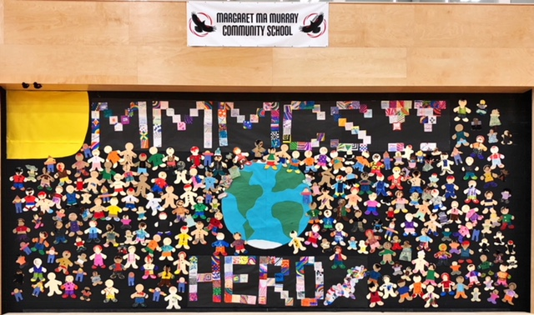

Calendar of Events for November
Margaret Ma Murray Community School
Monday | Tuesday | Wednesday | Thursday | Friday
29  Assembly @ 9:00 a.m. | 30 | 31  Halloween  Parade @ 1:00 p.m. | Nov 1 | Nov 2
5  Assembly @ 9:00 a.m.  Fire Drill @  2:20 p.m. | 6 | 7 | 8 | 9  Remembrance Day Service @ 11:00 a.m.
12  Remembrance  Day  School Closed | 13 | 14 | 15 | 16
19 | 20 | 21 | 22 | 23
26 | 27  Report Cards go home | 28  Early  Dismissal Day  School dismissed at 1:43 p.m. | 29  Early  Dismissal Day  School dismissed at 1:43 p.m. | 30  School Closed  Parent Teacher interviews
Right: →Grade 5/6 working on “Body Systems Projects”
Below:↓ Kindergarten students planting a rainbow of bulbs
