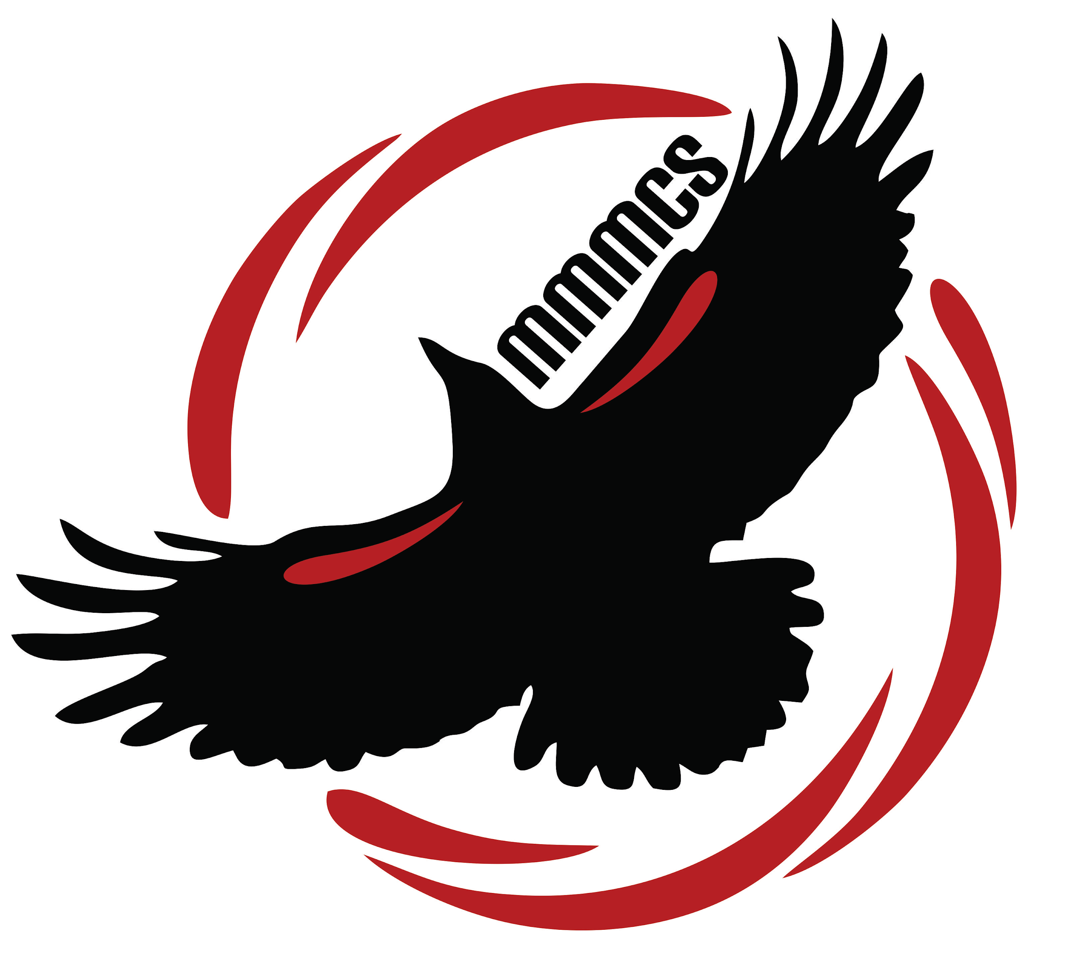
Margaret “Ma” Murray
Community School
11504 - 105 Avenue
Fort St. John BC V1J 0R8
236-365-6627

Wednesday, June 12, 2019

Dear parents and guardians,

How quickly the school year has come to an end. With two weeks left in the school year, there is a ton of activity in the school and a whole lot of excited students. Please find updates for the last two weeks along with some dates for September.

Lost and Found Items: These items are displayed in the Bella Yahey Gathering Space at the front of the school. Please come and have a look through this mountain of clothing, water bottles, boots, mitts and hats. We will bag up the left over items on Thursday, June 27th and they will be donated to a worthy cause.

June Calendar 2019

Monday Tuesday Wednesday Thursday Friday
17  Public library here all day – presentations to students  Grade 5-6 pod field trip | 18  PAC meeting and pot luck @ 6:30 pm  Bert Bowes here to perform a play for us @ 1:00 p.m. | 19 | 20  Indigenous Day  (Grade 5 students) | 21  Grade 12 Grad  Mrs. Bracey’s class to the Bennet Dam (all day)
24  Assembly @ 9:00 a.m.  Fun day 10:00-2:40 | 25  Kindergarten students on field trip all day  Festival of Colours @ 2 p.m. | 26 | 27  Last Day for Students  School Dismissed  @ 11:40  10:00 am assembly | 28  Last Day for teachers  Dismissal at 2:43

