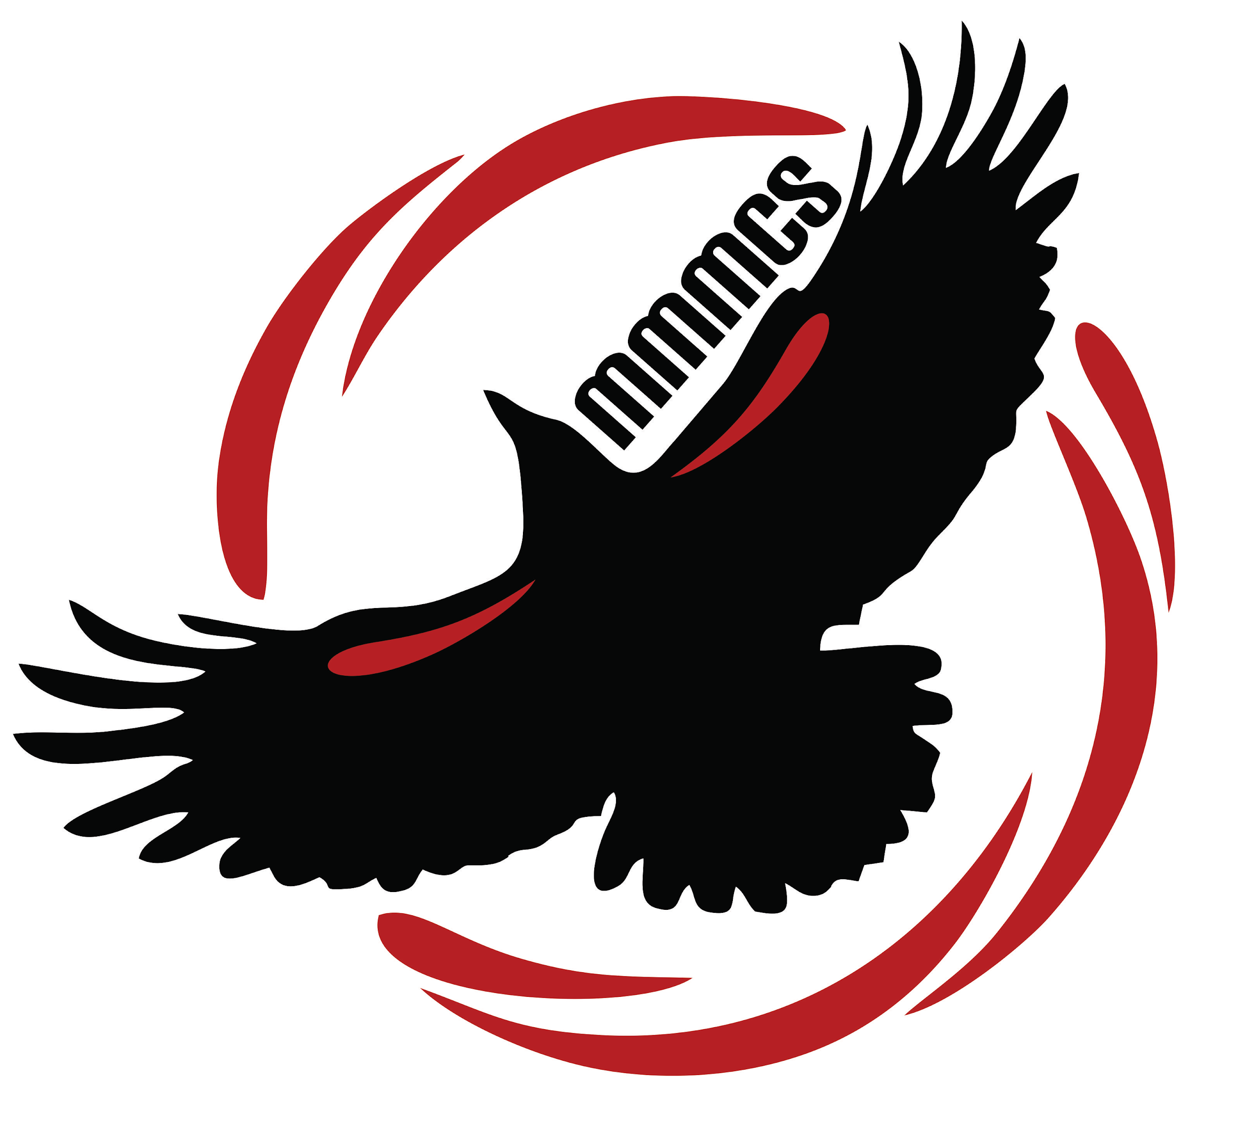
Margaret “Ma” Murray
Community School
11504 - 105 Avenue
Fort St. John BC V1J 0R8
236-365-6627

Tuesday, August 20th, 2019

Dear Parents and Guardians,

Welcome back to Margaret Ma Murray Community School year two. On behalf of the staff, I would like to say how excited we are to see all our students and families as we start our school year. We have been receiving a number of questions regarding opening day, school supplies and procedures. Hopefully this newsletter will help to address your questions and put your somewhat at ease for start-up.

The staff of the school have been working hard to plan for their classrooms, spirit day activities and back to school events. If you know of families who have moved in to our catchment area, the school will be registering students at the following times:

Monday, August 26th, 1:00-3:00 p.m.
Wednesday, August 28th, 9:00-3:00 p.m.
Thursday, August 29th, 9:00-3:00 p.m.
Friday, August 30th, 9:00-3:00 p.m.

Setting registration times will optimize our work day at the school so that we can give our new families undivided attention when you come to see us.

First Day Procedures: School will begin for grade 1-grade 6 on Tuesday, September 3rd. Students who will be arriving by bus will start arriving at 8:10 a.m. Students catching the bus at Ecole Central will need to be at the bus area at Central by 8:05 a.m. as the bus leaves at approximately 8:10 a.m. We will have a bus attendant there to meet the students. All students will be able to come in through the front door and check which pod they are assigned to. As we are unsure of the configuration of the school at this time (we are not sure which families have moved in or moved away), your child will be assigned to a teacher until Friday. At that time, we may have to do some shuffles if there are fluctuations in registrations. All classroom teachers will work together to make your child feel safe, secure and supported. Newly registered students will come to the office where one of our staff will welcome them, give them a tour of the school and help them find their pod. Dismissal on the first day will be at 10:40 a.m. Supervision will be provided to all bus students until their bus arrives to pick them up.

Kindergarten students will be on a gradual entry. The kindergarten teachers will be calling all families on Tuesday, September 3rd to explain the schedule for each child. Full day kindergarten begins on Wednesday, September 11th.

School Supplies: We have had many questions regarding school supplies. As per previous newsletters, we would like to offer school supplies to families at a cost of $35.00/child. This alleviates families from having to search out lists and supplies. We buy our supplies in bulk and as a result we get great prices, which we pass along to our families. It also ensures that students receive the supplies that their specific teacher wants to use.

School Fees: The School Board has approved our school fees for the 2019-2020 year as well as the School Calendar. We will begin collecting fees on Monday, September 9th as all of our accounting systems will be in place by then. Please see the school fee table along with the bell schedule below.

Cultural fees help to offset the cost of all the cultural performances that will be held in 2019-2020. Bus fees help to offset the cost for field trips, swimming lessons and skating trips. Students who bring their own supplies will be required to pay cultural fees, bussing fees and agenda fee.
Grade Level: | Supplies: | Cultural Fee: | Busing Fee: | Agenda: | Total Cost:
Kindergarten | $35 | $10.00 | $10.00 | Not applicable | $55.00
Grade 1-3 | $35 | $10.00 | $10.00 | $10.00 | $65.00
Grade 4-6 | $35 | $10.00 | $10.00 | $10.00 | $65.00
Other: | Camp Cameron:  $40.00 to offset the cost for the trip | Team Sports:  $20 for teams requiring  buses and referees | Field Trips:  Up to $10 for each field trip | Classroom with Technology Fee: Insurance Charge for Grade 6: As per board $35

2019-2020 Bell Schedule:

8:25 a.m. Regular Supervision begins 12:15 p.m. Lunch (students come in to eat)
8:40 a.m. Warning Bell 12:35 p.m. Warning Bell
8:45 a.m. Classes Begin 12:40 p.m. Classes begin
10:15 a.m. Recess 2:43 p.m. Dismissal
10:30 a.m. Warning Bell (5 minutes) 2:58 p.m. Playground supervision ends
10:35a.m. Classes Resume *students heading home**
11:55 a.m. Bell for going outside time*

Please see below, our Vision and Mission statement. These statements were developed with the staff in May, 2018. We strongly believe in our core values and work passionately in the focus areas. Behaviour expectations and our code of conduct will be the focus for much of our work at the school. Students in our school are H.E.R.O’s: Honest, Empathetic, Responsible and Open-Minded.

VISION STATEMENT
At Margaret “Ma” Murray Community School, our vision is to create a welcoming community that will provide creative, hands-on learning experiences. Students are empowered to become kind, inclusive, responsible, and curious lifelong learners.

MISSION STATEMENT
We are a caring community. We create, we learn, we collaborate!

CORE VALUES |  | FOCUS AREAS
Kindness  Responsibility  Curiousity  Perseverance  Acceptance |  | - Learners at the Center  - Whole Child  - Inclusion/Acceptance  - The Arts  - The 4 C’s: collaboration, communication, creativity,  critical thinking

Behaviour Expectations/Code of Conduct: Staff have worked with administration to put together our behaviour expectations and code of conduct. We will strive for excellence and will provide a safe and secure environment for all.

CODE OF CONDUCT

Margaret Ma Murray Community School

The purpose of our code of conduct is to maintain student rights and responsibilities

with expectations for behaviour during any school related activity.
All members of our school community are expected to:

Be Honest

Be Empathetic
Be Responsible
Be Open-Minded

Rights: | Responsibilities:
All members of our school community have the right to: | All members of our school community have the responsibility to:
- Be safe | - Behave in a safe manner at all times  - Tell an adult of incidents of bullying, harassment or intimidation
- Be accepted and respected | - Care for others and show respect
- Learn and achieve potential | - Listen to and respect others’ learning  - Pay attention in class and complete assignments  - Set and work towards goals
- Be heard and ask questions | - Listen to and respect others’ ideas  - Ask questions and share ideas politely and respectfully
- Work in a healthy, clean environment | - Keep the school clean and respect school property

Rising Expectations:
As students become older, more self-disciplined and mature, expectations regarding their behaviour and responsibility will rise accordingly. Older students are expected to set a good example for others.

Unacceptable Conduct  The following behaviours are some examples of conduct that is not acceptable and should not be considered a complete list.  Behaviours that:  - Are disrespectful to others  - Interfere with the learning of others  - Interfere with an orderly environment  - Create unsafe conditions  Acts of:  - Bullying, cyber-bullying, harassment, intimidation, threatening or violent behaviours  - Physical violence  - Retribution against a person who has reported such incidents  - Discrimination based on race, colour, ancestry, place of origin, religion, marital status, family status, physical or mental disability, sex, gender identity or expression, sexual orientation or age  Illegal acts, such as:  - Theft or damage to property | Consequences  There will be consequences for inappropriate behaviour.  Consequences will be determined based on the severity and frequency of the unacceptable conduct, and the age and maturity of the student.  Consequences will include restorative actions and could range from community service to suspensions. They will be logical and reasonable for the behaviour or action.

Notification
Parents of student offenders and victims, will be notified by school staff, when it is deemed necessary,
to reassure parents that we are aware of the incident and are taking appropriate actions to address
the incident. Multiple infractions of an expectation and serious infractions will be followed up with
a phone call home.

The school promotes the values expressed in BC Human Rights code respecting the rights of all individuals in accordance with the law. The school will treat seriously, behaviour or communication that discriminates based on race, colour, ancestry, place of origin, religion, marital status, family status, physical or mental disability, gender identity or expression, sexual orientation or age.

Margaret Ma Murray Community School
School Wide Expectations and Behaviour Matrix
A H.E.R.O. is an ordinary person doing extraordinary things.

 | Inside | Outside | Bathrooms | Technology
H  Honest | · I tell the truth.  · I do my best.  · I respect all property.  · I admit and correct my mistakes. | · I stay where adults are supervising.  · I tell the truth.  · I am fair. | · I use my own stall.  · I clean up after myself.  · I use the bathroom appropriately  · I report problems right away. | · I use technology appropriately.  · I am safe when I use the internet.  · I only use approved devices at school.
E  Empathetic | · I am kind, helpful and understanding.  · I respect the learning environment of others.  · I use kind words. | · I am an Upstander.  · I include others.  · I care for the environment.  · I am kind, helpful and understanding. | · I give people their privacy.  · I share the space properly. | · I offer help to others.  · I report cyber- bullying.  · I am kind and understanding to other users.
R  Responsible | · I keep my hands and feet to myself.  · I am where I should be.  · I stay organized and tidy my space.  · I work together with others. | · I play and learn safely.  · I use equipment properly.  · I listen and follow directions.  · I come in when the bell rings. | · I wait my turn.  · I clean up after myself.  · I flush the toilet and wash my hands.  · I am timely. | · I know using technology is a privilege.  · I stay on task.  · I take care of all school devices.
O  Open-Minded | · I embrace challenges and take risks.  · I learn about other people and cultures.  · I accept that others learn in different ways. | · I am open to new things.  · I seek out new friends. | · I give other’s privacy.  · I accept that everyone needs to use the washroom. | · I try new technology to complete my work.  · I share technology.

H.E.R.O.s join forces for the greater good!
The school mascot was chosen in May 2018. We are known as the redwing blackbirds a.k.a. “The Firebirds”. This mascot was chosen based on many conversations with district office and the staff of the school. We chose this bird based on its colour, the fact that it is a local bird and is found in nature throughout our region. We are proud to call ourselves “Firebirds”.
Although this information was sent out last August, it is important to revisit what the red winged black bird symbolizes. The Redwing Blackbird symbolism is letting us know that big changes are coming into our life right now. These changes have been slowly taking place all around us and these changes are now ready to burst forth and become reality. The redwing blackbird also symbolizes that we are all going to be part of a close-knit family or community and that this will lead to personal growth. Red winged blackbirds are supportive of each other. They also symbolize positive energy, new adventures and life experiences. It was wonderful to see these beautiful birds in the spring nesting at the pond near the school and in the bushes along the walking trail.
Bus Students: Many of the students will be arriving on buses. We have the tentative arrival schedule but not departure times. This schedule will be set up in early September once transportation knows how many students will be taking the bus. Any new families that require their children to ride the bus (i.e. you have moved in to the area for catchment or your child is in kindergarten and never taken the bus) will need to complete a transportation form. Any family who has had their physical address changed (currently on a bus route but have moved locations and have a new physical address) will also have to fill in a new transportation form. There will be supervision at the school when the students are dropped off and until they are on their bus for their return trip home. Transportation forms can be found at the district website at: http://www.prn.bc.ca/transportation/.

School Meals: M.M.M.C.S. will be offering a school meals program starting on September 16th. Menus will be coming home during September 12-14th so please watch for them. All directions will be included in the menu paperwork. This is a successful program provided for by the district and we look forward to providing this option for your families.

Wednesday, September 4th will be a full day for students. Please remember to pack a lunch, a water bottle and inside shoes. I encourage all families to place their child’s name inside with a permanent marker to help the children keep track of their shoes. I have included a calendar for September with the dates we know so far. I look forward to meeting all families as you arrive on the first day of school. I am hoping you are all as excited as I am for the second year at MMMCS. Enjoy your last weeks of summer holidays!

Sincerely,

Mrs. Kathy Scheck Mr. Hunter Mackay
Principal Vice Principal
Margaret Ma Murray Community School

September 2019
Calendar of Events
MMMCS

Monday | Tuesday | Wednesday | Thursday | Friday
August 26  School opens for registrations | 27  registrations only 1-3 p.m. | 28 | 29 | 30
2 | 3  First Day of School  Dismissal @ 10:40 | 4  First full day of school | 5 | 6
9 | 10 | 11  First full day of kindergarten | 12 | 13
16  School Meal Program begins | 17 | 18 | 19 | 20  Non-Instructional Day Planning
23  Canteen begins | 24 | 25 | 26 | 27
30

