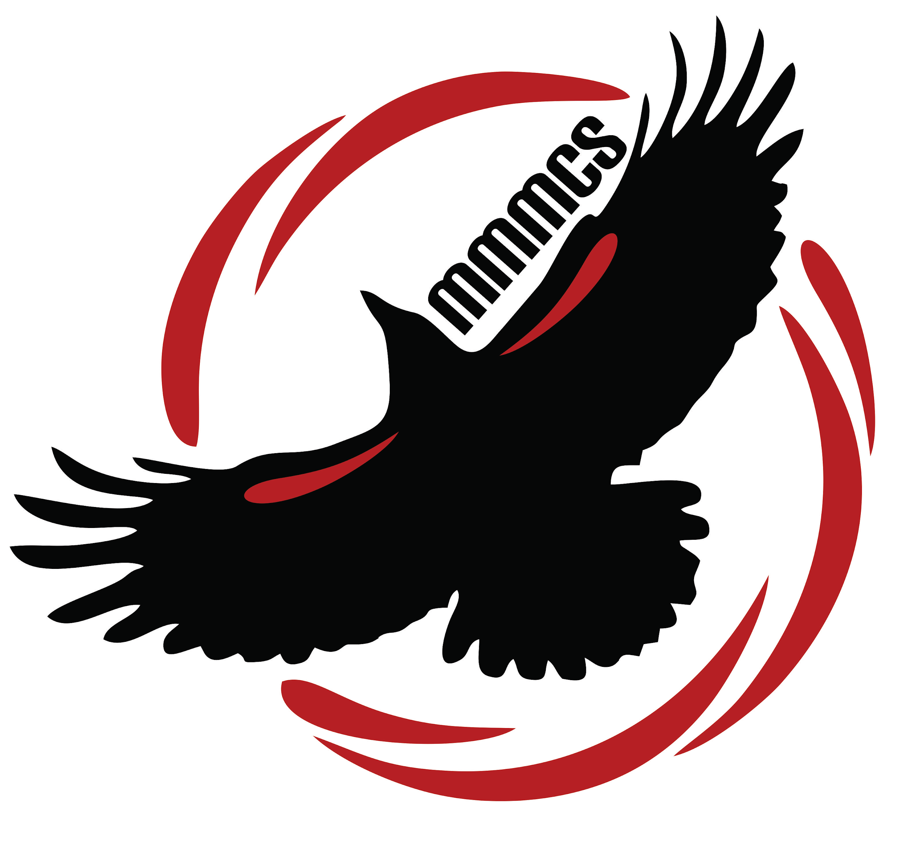
Margaret “Ma” Murray
Community School
11504 - 105 Avenue
Fort St. John BC V1J 0R8
236-365-6627

Monday, September 16th, 2019

Dear Parents and Guardians,

What a great start up we have had to year two! Students and staff seem to be settling in nicely. We are so blessed with a fantastic start to the school year, including a great “Purple Potato Soup”, potato salad and nectarines we shared on Friday. Thank you to all the hands who helped prepare this food, cleaned up dishes, and the garden space that provided our potatoes.

P.A.C. Meeting: Please join the P.A.C. (Parent Advisory Council) on Wednesday, September 18th at 6:30 p.m. for the very first P.A.C. meeting of the year. All parents and guardians are welcome to attend. Your voice is needed to make our school great.

School Meals Program: Students who have signed up for school meals will have their meals delivered to their classroom starting Monday, September 16th. Menus
for October will go out shortly. The canteen will also be open as of Monday. We have listed items available at the end of the newsletter. Families who want to order hot lunches, please follow the link at:

Forms: Last week you received many forms. Some classes were able to get these out on Thursday with the balance of classes sending the forms home this week. Please return these forms as soon as possible. Students also brought home fee schedules. This outlines what your fees are for the school year including: school supplies, bus , cultural, agenda and for grade 6 ipad fees. Families who have paid fees will see their fees paid. The district was hoping to have a program called Activity Right set up for families to pay fees and do permission slips through. There is a delay in the program and will update you when that occurs. In the meantime, please pay your fees as soon as possible at the office. We are set up for cash or check only.

Mountain West Photos: School pictures will be taken on Thursday, September 26th. Students received order forms last week and we ask that these be returned prior to picture day. There is a discount coupon you can pick up from the office if you have 3 or more children receiving pictures through Mountain West. Please drop by the office if you qualify for this discount.

Sports Programs: Thank you to Mrs. Logeman and Miss Jaimelia for support our after school programs by volunteering to coach cross country running. Our students are fortunate that these programs are offered. Over 40 students are participating in these runs and will participate in the district meets.

H.E.R.O.: The school has been using a H.E.R.O. theme with the students over the past two weeks. This relates to our Code of Conduct, behaviour matrix, and is encouraging all students to be an everyday hero like Margaret Ma Murray and Terry Fox. We will focus some of our assembly time and classroom instructional time to discussing everyday heroes like Terry Fox. A hero is classified as an everyday person doing extra-ordinary things. We encourage families to talk about what a regular person can do to help the world in the smallest of ways. Together we can make this world a better place.

Terry Fox Run:. Our school will participate in the annual Terry Fox Run on Thursday, September 26th. This is the day set aside for schools across Canada to participate together. September is also the month where there is a focus on raising funds and awareness for childhood cancers. Leadership students will host a bake sale from September 23-27th to help raise funds to support research and children with cancer. Donations of baked goods are welcome and can be dropped off at the office. We will also be doing a “Toonies for Terry” campaign. Our goal is to raise $682.00, which is one toonie for each student in our school. Thank you for your support of these worthy causes.

Orange Shirt Day: Over the next few weeks, students will be learning about residential schools and Orange Shirt Day. This day has been set aside to re-affirm
that “Every Child Matters”. Phyllis Webstad, the author of The Orange Shirt Story, writes about her experience at a residential school in B.C. She can be
considered a HERO as she brings knowledge and understanding regarding residential schools and the truth and reconciliation process in Canada. Please see the website link http://www.orangeshirtday.org/ to learn more about this important day in our Canadian history. Orange Shirt Day will be recognized district wide on Monday, September 30th. We encourage all children to wear orange that day and join in.

Open House: Please join us on Thursday, September 19th from 5:30-6:30 p.m. at our Open House. This is a chance to meet the staff and tour the school. We look forward to meeting you.

First Anniversary Assembly will be held on Friday, September 27th at 9:00 a.m. This is the anniversary of our official grand opening. Students and staff will be presenting a few songs at this time. Please join us if you are able to.

Reminder: School zones are in affect. Please drive responsibly, both in our parking lot and on the roads.

We look forward to meeting all families before the end of September.

Sincerely,

Mrs. Kathy Scheck Mr. Hunter Mackay Mrs. Linda Gibos
Principal Vice Principal Secretary

Margaret Ma Murray Community School

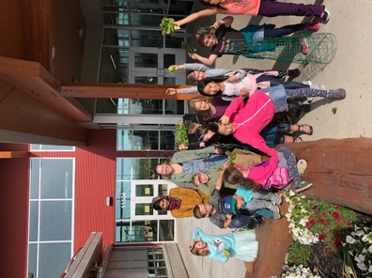
Updated Monthly Calendar

Monday | Tuesday | Wednesday | Thursday | Friday
16  Assembly @ 9 am | 17 | 18  P.A.C. meeting @ 6:30 p.m. | 19  International Pirate Day  Dress like a pirate and eat pancakes  Open House 5:30-6:30 p.m. | 20  Non-Instructional Day  School Closed
23  Bake Sale Week to support kids with cancer | 24 | 25 | 26  School pictures  RR training  (1 pm CP)  Terry Fox run @ 2 pm | 27  1st Anniversary of our Grand Opening  Assembly @ 9 am
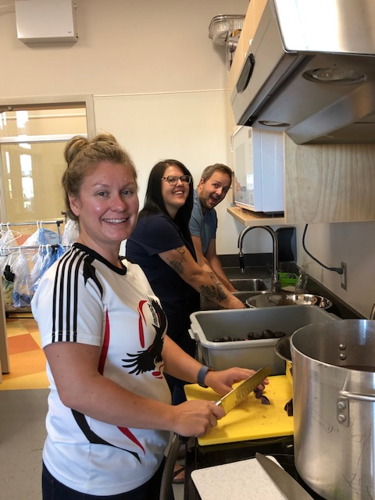
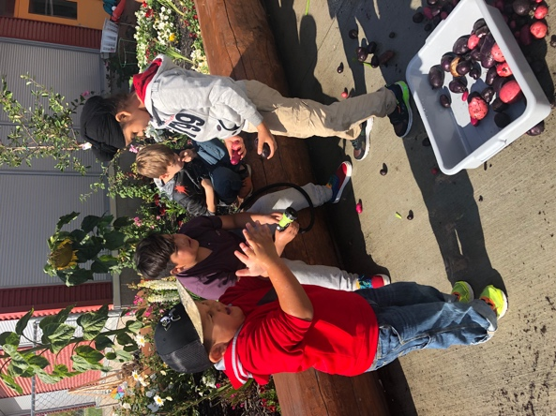
Left: Washing potatoes for soup
Right: Making potato soup

Leadership Updates:

Happy Fall!

This year in leadership, I am pleased to announce we will be partnering with the Rotary Club, and starting an Early Act club at school. The leadership group will still in charge of spirit days and organizing fundraisers for the community, both here and abroad. This term we will be doing the following fundraisers:

- Monday, September 23- Friday, September 27- We will be having a bake sale for local families with children affected by cancer. We are asking for donations of baked goods all week. The items will be on sale in the Bella Yahey at recess and lunch, and all items will be $1.00.
- Monday, September 30- Friday, October 4- We will be doing a Winter Gear Drive and are asking for donations of good conditioned winter coats, snow pants, gloves, hats, scarves and boots. We will have them available for the community on Friday, October 4 from 3:30pm to 6:30pm, as well as, on Saturday, October 5 from 2:30pm to 5:00pm. Any parent volunteers would be greatly appreciated.
All of October, we will be collecting items for the Operation Shoebox. We will be collecting items to send overseas to help children in orphanages. There will be a collection box set up outside of the library. Please see attached sheet for more information.
